Basic Concepts of Probability

Experiment: Experiment is an act that can be repeated under given conditions.

Outcomes: The result of an experiment is known as outcomes.
Ex: Throwing a die is a trial and getting 1 or 2 or 3 or 4 or 5 or 6 is an outcome
Possible outcomes: The numbers 1, 2, 3, 4, 5, 6

Mutually Exclusive Outcomes: Outcomes or cases are said to be mutually exclusive if the happening of any one of them precludes the happening of all others. Example-1) In tossing a coin, the outcomes hear and tail are mutually exclusive.2) In throwing a die, the six outcomes which are the different points on the faces of the die is mutually exclusive.

Equally likely Outcomes: Outcomes of a trial are said to be equally likely if we have no reason to expect any one rather than the other. Example-1) In tossing a fair coin, the outcomes head and tail are equally likely,2) In throwing a balanced die all the six faces are equally likely.

Event: An Event is the collection of one or more outcomes of an experiment.
One possible event: The occurrence of an even number. That is, we collect the outcomes 2, 4, and 6.

Sample space: A sample space is the set of all outcomes.
Example
- If we throw a die the outcomes are 1, 2, 3, 4, 5 and 6. Then 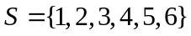 is a sample space.
- If we toss a coin then the outcomes are head (H) and tail (T). Then 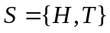 is a sample space.

There are three definitions of probability: classical, empirical, and subjective.

Classical or mathematical Probability:
If there are n mutually exclusive, equally likely and exhaustive outcomes of an experiment and if m of these outcomes are favorable to an event A, then the probability of the event A which is denoted by 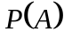is defined by
= Favorable outcomes of an event A/Total number of outcomes of the experiments
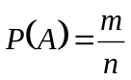
Example: After tossing a coin what is the probability that we will get head?

Solution:
We know,
Here total number of outcome is n= 2 and favorable outcome, m=1
So 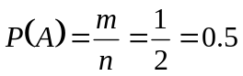
Example: Tickets are numbered from 1 to 100. They are well shuffled and a ticket is drawn at random. What is the probability that the drawn ticket has
- An odd number
- A number 4 or multiple of 4
- A number which is greater than 70 and
- A number which is square?

Solution

Since there are 100 tickets, the total number of exclusive mutually exclusive and equally likely case is 100.

- Let  denote the event that the ticket drawn an odd number. Since there are 50 odd number tickets so the number of cases favorable to the event is 50.
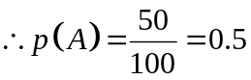.

- Let  denote the event that the ticket drawn has a number 4 or multiple of 4. The numbers favorable to event are 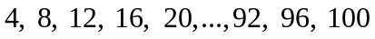. The total number of cases will be 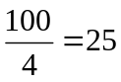.
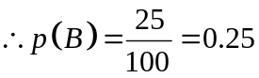.

- Let  denote the event that the drawn ticket has a number greater than 70. Since the number greater than 70 are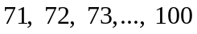. Therefore, 30 cases are favorable to the event .
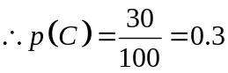.
- Let  denote the event that the drawn ticket has a number which is a square. Since the squares between 1 and 100 are 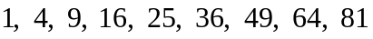 and 100. So the cases favorable to event are 10 in number. Hence,
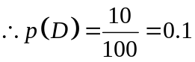.

Empirical or statistical probability:
If an experiment is repeated a large number of times under the same conditions, then the probability of an event A is the limiting value of the ratio of the number of times that the event A happens to the total number of trails, as the number of trails increases indefinitely large, provided the ratio approaches a finite and unique limit.
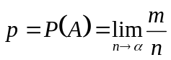
Example: Throughout her teaching career Professor Jones has awarded 186 A’s out of 1,200 students. What is the probability that a student in her section this semester will receive an A?

Solution: To find the probability a selected student earned an A:
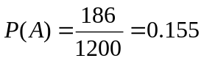

Subjective probability is based on whatever information is available.

Laws of Probability:
There are two laws which are very important.
- All probabilities are between 0 and 1 inclusive

i.e. 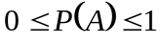
- The sum of all the probabilities in the sample space is 1

i.e. 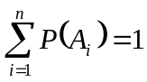

Probability Rules:
- Specific Addition Rule
If two events are mutually exclusive, then the probability of either occurring is the sum of the probabilities of each occurring.
P (A or B) = P (A) + P (B).

Example on probabilities:

Example: A bag contains 4 white, 6 black balls and 5 green balls. If one ball is drawn at random from the bag, what probability that it is 1) black, 2) white, 3) white or black.

Solution: Total numbers of balls are 15.Since one ball is draw from the bag; there are 15 mutually exclusive, equally likely and exhaustive outcomes of this experiment.

1) Let A be the event that the ball is black, and then the number of outcomes favorable to A is 6.hence

P (A) =Number of black balls/Total number of balls=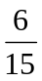=0.4.

2) Let B be the event that the ball is white, and then the favorable outcomes corresponding to B is 4.Therefore

P (B) =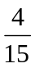=0.266

3) Let C be the event that the ball is white or black, then

P(C) =P (A or B) =+=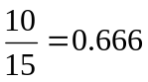
Example
If we toss a coin then what is the probability of head or tail?

Solution
Here there are two events, namely event = and event =. So that

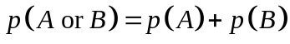
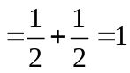.

General Addition Rule:

In events which are not mutually exclusive, there is some overlap. When P (A) and P (B) are added, the probability of the intersection (and) is added twice. To compensate for that double addition, the intersection needs to be subtracted.
P (A or B) = P (A) + P (B) - P (A and B)
Example:
In a sample of 500 students, 320 said they had a stereo, 175 said they had a TV, and 100 said they had both. 5 said they had neither. If a student is selected at random, what is the probability that the student has only a stereo or TV? What is the probability that the student has both a stereo and TV?

Solution: Let S and T be the events that students had stereo and TV, respectively. Then the probability that student has only stereo or TV is-
P(S or T) = P(S) + P (T) - P(S and T)
= 320/500 + 175/500 – 100/500
= .79.
The probability that the student has both a stereo and TV
P(S and TV) = 100/500
= .20
Example
Mr. X feels that the probability that he will pass Mathematics is  and Statistics is . If the probability that he will pass both the course is . What is the probability that he will pass at least one of the course?

Solution
Let  and be the events that he will pass the courses Mathematics and Statistics respectively. The event  means that at least one of or occurs. Therefore
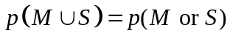
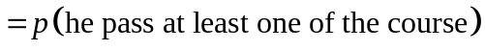
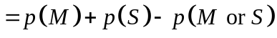
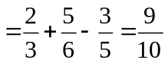.

Exercise: A student is taking two courses, history and math. The probability the student will pass the history course is .60, and the probability of passing the math course is .70. The probability of passing both is .50. What is the probability of passing at least one?

Specific Multiplication Rule:
The Specific Rule of Multiplication requires that two events A and B are independent.
This rule is written: P(A and B) = P(A)*P(B)
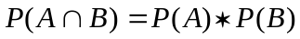
Example:
A company has two large computers. The probability that the newer one will breakdown on any particular month is 0.05, the probability that the older one will breakdown on any particular month is 0.1. What is the probability that they will both breakdowns in a particular month?
Solution
Let, Event is the newer one will breakdown and Event is the older one will breakdown. So that 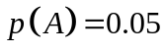 and 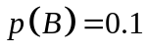.

.

General Multiplication Rule

The General Rule of Multiplication requires that two events A and B are dependent
P (A and B) = P (A) * P (B|A)
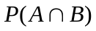= P (A) * P(B|A)
Example
There are 10 rolls of film in a box, 3 of which are defective. Two rolls are to be selected one after another. What is the probability of selecting a defective roll followed by another defective roll?

Solution
The first roll of film selected from the box being found defective is event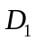. 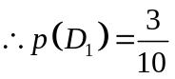.
The second roll selected being found defective is event 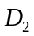. Therefore, 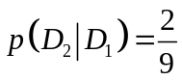. Since, after the first selection was found to be defective, only 2 defective rolls of film remained in the box containing 9 rolls.

So the probability of two defectives is
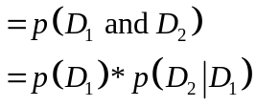
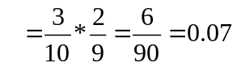.
Complement rule

The complement rule is used to determine the probability of an event occurring by subtracting the probability of the event not occurring from 1 i., e. 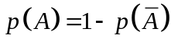.

Example

Weight | Event | Probability
Underweight | A | 0.025
Satisfactory | B | ??
Overweight | C | 0.075

Find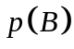.
Solution
We know that 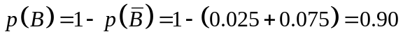.
Example: Rahim can hit a target 5 out of 7 chances. Karim can hit a target 6 out of 11.Find the chances that the target is hit once they both try?
Solution:
Suppose
P(A)=Probability that Rahim can hit the target=5/7
P()=Probability that Rahim cannot hit the target=1-5/6=2/7

P(B)=Probability that Rahim can hit the target=5/7
P(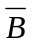)=Probability that Rahim cannot hit the target=1-5/6=2/7
The probability that no one can hit the target is =P(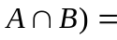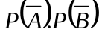=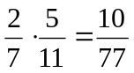
So,the chances that the target is hit one is =1- P(1- 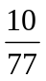=67/77=.87

Joint probability:
Joint probability is the probability of two events in conjunction. That is, it is the probability of both events together. The joint probability of A and B is written P (A and B) or.
Example:
The question, "Do you like watching TV?" was asked of 100 people. Results are shown in the table. What is the probability of a randomly selected individual being a male who likes watching TV?
 | Yes | No | Total
Male | 19 | 41 | 60
Female | 12 | 28 | 40
Total | 31 | 69 | 100

Solution: This is just a joint probability. The number of "Male and like watching TV" divided by the total = 19/100 = 0.19

Marginal probability:
Marginal probability is the probability of A, regardless of whether event B did or did not occur. If B can be thought of as the event of a random variable X having a given outcome, the marginal probability of A can be obtained by summing the joint probabilities over all outcomes for X.

Example:

The question, "Do you like watching TV?" was asked of 100 people. Results are shown in the table. What is the probability of a randomly selected individual like watching TV?
 | Yes | No | Total
Male | 19 | 41 | 60
Female | 12 | 28 | 40
Total | 31 | 69 | 100
Solution:
Since no mention is made of gender, this is a marginal probability, the total who like watching TV divided by the total = 31/100 = 0.31.
Conditional probability
Let and be two events. The conditional probability of event given that has occurred, is defined by the symbol 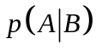 and is found to be:

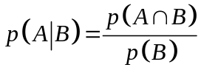; provided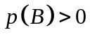.

Similarly, 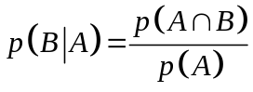; provided 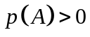.

Example
A hamburger chain found that 75% of all customers use mustard, 80% use ketchup and 65% use both. What are the probabilities that a ketchup user uses mustard and that a mustard user uses ketchup?

Solution
Let be the event “customer uses mustard” and be the event “customer uses ketchup”. Thus, we have, 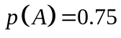, 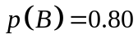 and 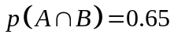.

The probability that a ketchup user uses mustard is the conditional probability of event , given event is

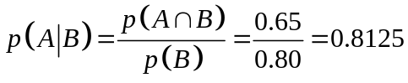.
Similarly, the probability that a mustard user use ketchup is
Example: The question, "Do you like watching TV?" was asked of 100 people. Results are shown in the table. What is the probability of a randomly selected individual is a male if it is given that he likes watching TV?

 | Yes | No | Total
Male | 19 | 41 | 60
Female | 12 | 28 | 40
Total | 31 | 69 | 100

Solution: The conditional probability M given Y is

P (M|Y) =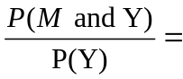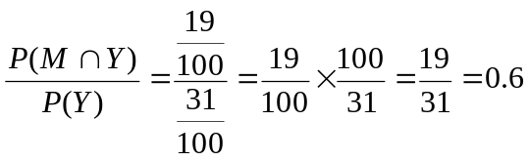

Bayes Theorem

If 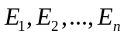 are mutually disjoint events with 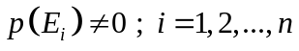 then for any arbitrary event which is a subset of 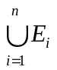 such that, we have

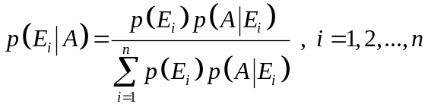.
E₁ | E₂ | ……….. | E_{n}
A

Example

In a bolt factory machines 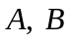 and manufacturer respectively 25%, 35% and 40% of the total. Of their output 5, 4 and 2 percent are defective bolts. A bolt is drawn at randomly from the product and is found to be defective. What are the probabilities that it was manufactured by machines and ?

Solution

Let 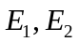 and 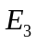 denote the events that a bolt selected at random is manufactured by the machines and respectively and let  denote the event of its being defective. Then we have, 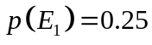, 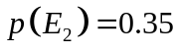 and 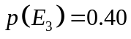.

The probability of drawing a defective bolt manufactured by machine is 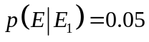. Similarly, we have 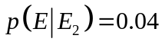 and 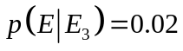.

Hence, the probability that a defective bolt selected at random is manufactured by machine is given by

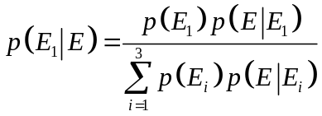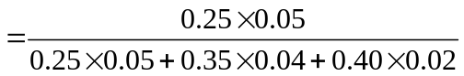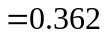

Similarly, 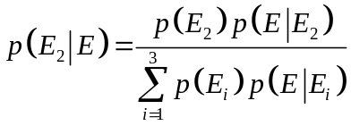 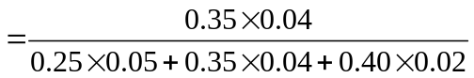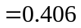

and 